**EX.NO:7.4 MODULES DESCRIPTION**

**DATE:**

**MODULES DESCRIPTION:**

There are three modules in this kids learning website. These modules comprises of the contents which will be very useful for the kids to enhance their basic knowledge in all aspects. The modules are

1. Language Module
2. Subjects Module
3. General knowledge

**LANGUAGE MODULE:**

Language means “The method of human communication, either spoken or written, consisting of the use of words in a structured and conventional way”. It enables us to express our wishes, feelings, likes, dislikes, and idea its symbolic function. This language achieves by encoding and externalizing our thoughts. So language plays important role in our life. Every child should learn at least two languages.

Through this website, kids can learn Tamil and English. In both languages, they will learn basics.i.e letters like”A”,”B”…..etc and அ, ஆ…etc. All these contents will be available as an animated one.GIF images are used here to attract kids to learn alphabets in English and letters in Tamil. English as well as Tamil rhymes are also here in the form of videos which will be very attractive and interesting for the kids to learn.

 Children who are exposed to language training show measurable improvements in other cognitive skills.  Researchers believe that early language exposure actually increases the size and power of a child's brain. [Children learning an additional language](http://www.kumon.co.uk/blog/encouraging-children-to-learn-another-language/) are more creative, better at solving complex problems and usually score higher on standardized tests.

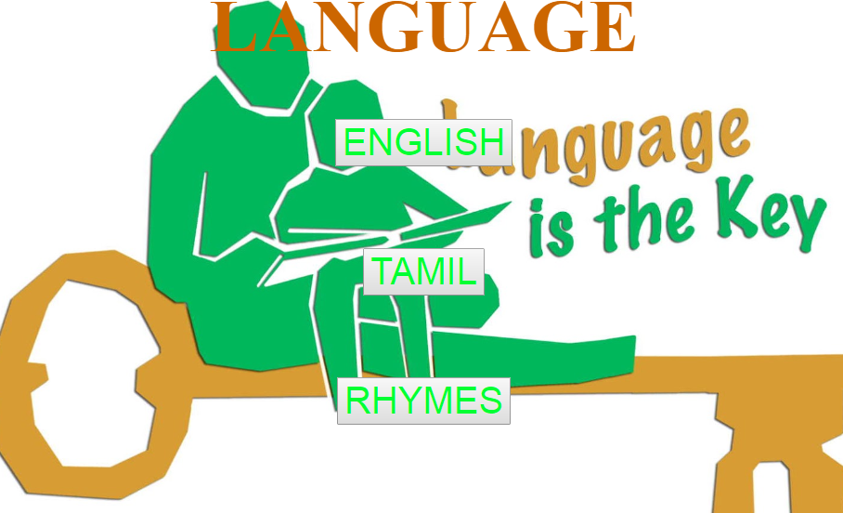

Fig 7.4.1 Language Module

**SUBJECTS MODULE:**

In this module, two subject contents were given for the kids to learn. Two subjects are Maths, Science. Numbers from 1 to 10 are given under the maths module whereas images for fruits, vegetables, colours, parts of the body, hygiene techniques. All these contents are explained using images which will explain the exact thing to kids. As growing kid, it is very necessary for them to know about the parts of the body and hygiene techniques.

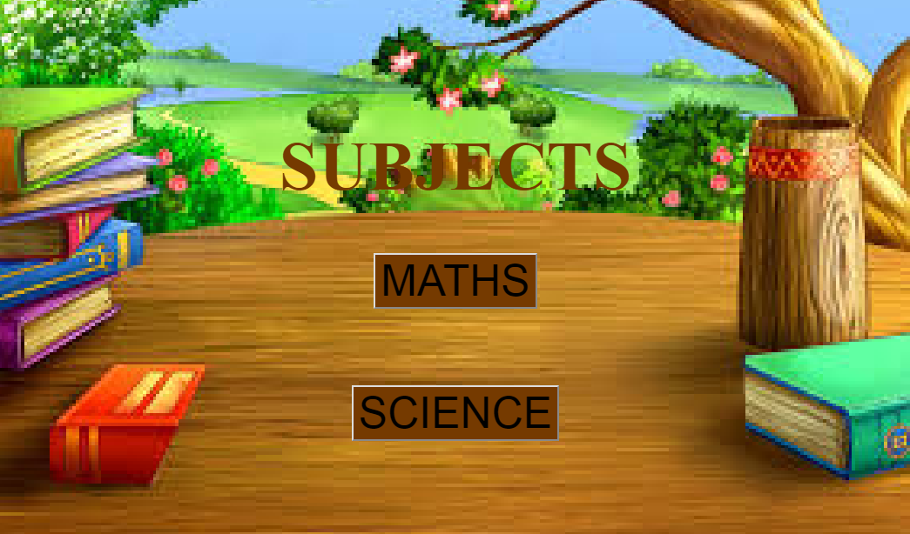

**GENERAL KNOWLEDGE MODULE:**

In this module, information about our nation and state are provided as contents for the kids to know a little about our nation and our state. Information about the ministers of India and Tamilnadu are given here. General information about our nation like national emblem, national bird, national animal .Etc

